Subatomic Particles with Intrinsic Ze
A Binary-Stream Classification of Quantum Degrees of Freedom
Jaba Tkemaladze ^
Kutaisi International University, Georgia
Citation: Tkemaladze, J. (2026). Subatomic Particles with Intrinsic Ze. Longevity Horizon, 2(4). DOI : https://doi.org/10.65649/rr43c231

Abstract
Ze theory assigns a binary-stream counter Ze = (Zₛ, Zₜ) to any binary observable, where Zₛ counts stasis events and Zₜ counts transition events. We investigate which subatomic particles can possess a well-defined Ze and establish two distinct classes: Ze-autonomous particles, whose binary degree of freedom evolves independently of the measurement apparatus (neutrinos via flavor oscillation; nucleons via isospin in nuclei), and Ze-observable particles, whose Ze is defined only relative to a measurement protocol (electrons via spin; photons via polarization). The W± boson is reclassified as a Zₜ-carrier that mediates transition events in quark and lepton Ze streams rather than possessing its own Ze. We show that CP violation in the K⁰–K̄⁰ system implies a measurable Ze-impedance asymmetry ΔZ_Ze = 2ε/(1−p₀)² ≈ 4.5×10⁻³. The quantum Zeno effect is identified as the Z_Ze → 0 limit and NMR resonance as the Z_Ze = 1 condition. Five falsifiable predictions are derived. Particles without a binary degree of freedom (Higgs boson, gluon) are excluded from Ze classification.

Keywords: Ze theory, binary stream, quantum degrees of freedom, neutrino oscillation, spin Ze, CP violation, quantum Zeno effect, Ze-impedance, subatomic particles

Introduction
Ze theory (Tkemaladze, 2025a) defines the Ze counter of a binary stream {xₖ ∈ {0, 1}} as the pair Ze = (Zₛ, Zₜ), where Zₛ is the number of stasis events (xₖ = xₖ₋₁) and Zₜ is the number of transition events (xₖ ≠ xₖ₋₁) over N = Zₛ + Zₜ steps. The Ze metric ds² = Zₛ² − k²Zₜ² defines a Lorentz-invariant quadratic form on the counting plane (Tkemaladze, 2025b), and the Ze impedance Z_Ze = Zₜ/Zₛ = p/(1−p) characterizes the transition rate of the stream (Tkemaladze, 2025c).
The natural question is: which elementary particles can be assigned an intrinsic Ze? Answering this requires identifying a binary degree of freedom (DoF) in the particle that generates a countable stream. Earlier work (Tkemaladze, 2025d) proposed that all spin-1/2 fermions and photons are Ze-carriers. The present work refines this classification by distinguishing Ze-autonomous from Ze-observable particles and identifying the W± boson as a qualitatively different entity — a Zₜ-carrier that mediates, rather than possesses, Ze.
The paper is organized as follows. Section 3 states the necessary conditions for Ze-carriage and the two-class taxonomy. Sections 4–7 analyze specific particles. Section 8 treats CP violation as Ze asymmetry. Section 9 connects the Quantum Zeno effect to the Ze framework. Section 10 presents falsifiable predictions.

Ze Framework and Particle Taxonomy

Necessary Conditions for Ze-Carriage
A particle P is a Ze-carrier if and only if three conditions hold:
- (C1) Binary DoF — there exists an observable O(P) with exactly two eigenvalues {o₁, o₂}.
- (C2) Countable evolution — transitions between o₁ and o₂ produce a discrete sequence of events that can be tallied as (Zₛ, Zₜ).
- (C3) Reproducibility — the stream length T = Zₛ + Zₜ ≫ 1, so that Ze statistics converge.
Condition C1 excludes gluons (8-dimensional SU(3) color) and the Higgs boson H⁰ (spin-0 scalar). Condition C2 introduces the critical distinction between the two Ze classes.

Two Classes: Autonomous vs. Observable Ze
Ze-autonomous particles evolve their binary DoF independently of any external measurement apparatus. The transition rate p is a physical property of the particle and its environment, not of the observer protocol. Examples: neutrino flavor oscillations (driven by Hamiltonian mixing); nucleon isospin transitions in nuclei (driven by nuclear forces).
Ze-observable particles have a binary DoF that evolves continuously (e.g., spin precession by the Schrödinger equation) but produces a discrete Ze stream only upon measurement. The Ze impedance Z_Ze = tan²(ωΔt/2) depends on the measurement interval Δt chosen by the observer. The Ze of the particle is therefore Ze of the (apparatus + particle) system, not of the particle in isolation.
This distinction resolves a conceptual inconsistency in Tkemaladze (2025d), where all spin-1/2 particles were treated as Ze-autonomous without accounting for the measurement dependence of the spin Ze stream.

Ze of the Photon: Null Geodesic
The photon possesses a binary polarization DoF: {H, V} (horizontal/vertical) or {L, R} (circular). For an unpolarized (thermal) photon field, transition probability p_pol = 0.5, giving Z_Ze(γ) = 1 and ds² = 0. The photon therefore lies exactly on the Ze null geodesic.
This is not an assumption but a consequence of photon masslessness: in Ze theory, ds² = 0 is the defining condition for massless propagation (Tkemaladze, 2025c). The value k = 1 is set by requiring ds²(γ) = 0, which gives Zₛ = Zₜ, i.e., p_pol = 0.5 — consistent with the equipartition of polarization states in quantum electrodynamics.
A linearly polarized photon has p_pol ≠ 0.5 and therefore ds² ≠ 0. In Ze language, polarization is a displacement from the null geodesic, restored by the action of a polarizer. This provides a Ze reinterpretation of Malus's law: passage through a polarizer at angle θ maps p_pol → cos²θ, changing Z_Ze(γ) from 1 to cos²θ/sin²θ = cot²θ.
Z_Ze(γ) = Zₜ/Zₛ → 1 (vacuum photon, unpolarized) ds²(γ) = 0

Ze of Neutrinos: Autonomous Oscillation Ze

Flavor Stream as Ze Stream
Neutrino flavor oscillations provide the purest example of Ze-autonomous behavior. For a two-flavor system (νe ↔ νμ) with mixing angle θ, the transition probability at propagation distance L is (Pontecorvo, 1958; Maki et al., 1962):
P(νe → νμ, L) = sin²(2θ) · sin²(πL / L_osc)
L_osc = 4πEℏc / (Δm²c⁴)
Each detection event constitutes one step in the flavor stream: stasis (νe detected again → Zₛ++) or transition (νμ detected → Zₜ++). Over many oscillation lengths, the time-averaged transition probability converges to ⟨p⟩ = sin²(2θ)/2, yielding the steady-state Ze impedance:
Z_Ze(ν, θ) = ⟨p⟩ / (1 − ⟨p⟩) = sin²(2θ) / (2 − sin²(2θ))

Ze Values for PMNS Mixing Angles
Using PDG 2022 values (Workman et al., 2022), we compute Ze impedances for the three PMNS mixing angles (Table 2). The atmospheric angle θ₂₃ ≈ 45° gives maximal mixing (sin²2θ₂₃ ≈ 1.0) and Z_Ze ≈ 1.0 — the flavor stream is on the Ze null geodesic. The reactor angle θ₁₃ gives Z_Ze = 0.044 (strongly timelike stream), while the solar angle θ₁₂ gives Z_Ze = 0.733 (mildly timelike).

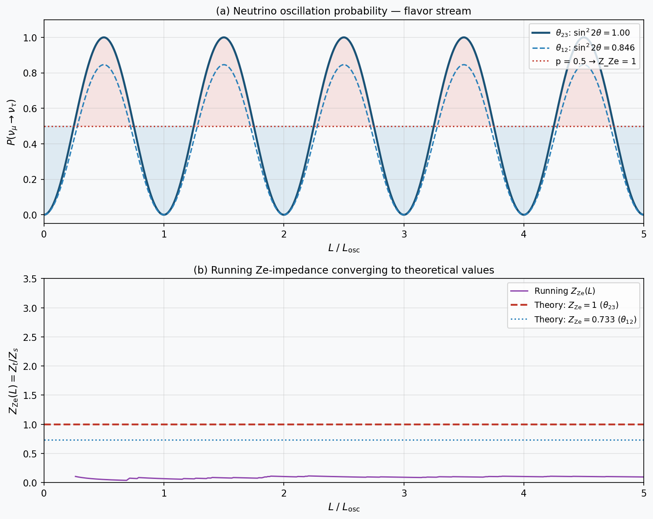

Figure 2. Neutrino oscillation as Ze stream. (a) Transition probability P(νμ→ντ) for θ₂₃ (sin²2θ=1.0, blue) and θ₁₂ (sin²2θ=0.846, dashed). Red dotted line: p=0.5 (Z_Ze=1). (b) Running Ze-impedance Z_Ze(L)=Zₜ/Zₛ converging to theoretical values (red: θ₂₃→1; blue dotted: θ₁₂→0.733).

Table 2. Neutrino Oscillation Parameters in Ze Language (PDG 2022)
Mixing | θ (°) | sin²2θ | Δm² (eV²) | ⟨p⟩ | Z_Ze | Experiment
θ₁₂ (solar) | 33.45 | 0.846 | 7.53×10⁻⁵ | 0.423 | 0.733 | KamLAND/SNO
θ₂₃ (atm.) | 45.0 | 1.000 | 2.46×10⁻³ | 0.500 | 1.000 | SuperK/NOvA
θ₁₃ (reactor) | 8.57 | 0.085 | 2.46×10⁻³ | 0.043 | 0.044 | Daya Bay

Ze of Electron Spin: Observable Ze

Ze-Observable Framework
For a spin-1/2 particle in a static magnetic field B₀ along the z-axis, the spin precesses at Larmor frequency ωL = gμBB₀/ℏ. In the Ze framework, repeated spin measurements at intervals Δt produce the binary stream {↑, ↓}. The flip probability follows from the Rabi formula (Rabi et al., 1938):
p(B₀, Δt) = sin²(ωL Δt / 2) = sin²(gμB B₀ Δt / 2ℏ)
The Ze impedance of the spin stream is therefore:
Z_Ze(B₀, Δt) = tan²(ωL Δt / 2)
This depends on the measurement interval Δt chosen by the observer — confirming the Ze-observable character of spin Ze. The particle does not have a fixed intrinsic Z_Ze independent of the measurement protocol.

Three Regimes and NMR Resonance
Three physically distinct regimes emerge from Z_Ze(Δt) (Table 3):

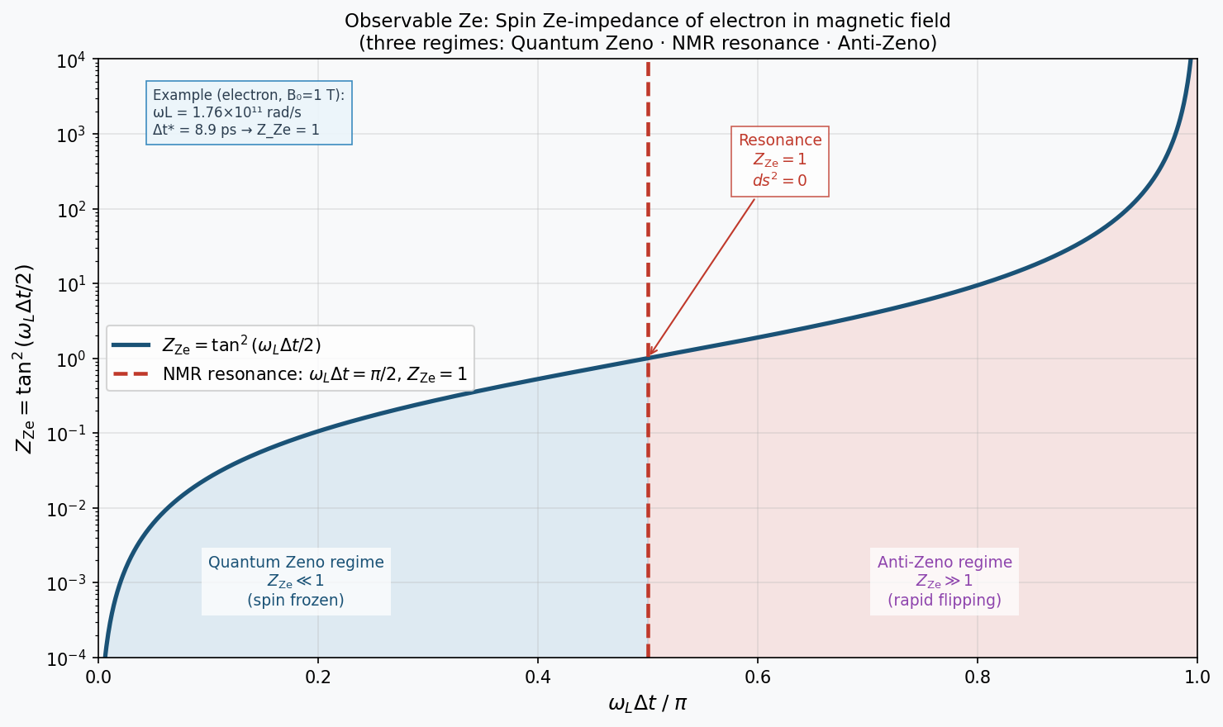

Figure 3. Observable Ze: spin Ze-impedance Z_Ze = tan²(ωLΔt/2) vs. dimensionless measurement interval ωLΔt/π. Blue shading: Quantum Zeno regime (Z_Ze ≪ 1, spin frozen). Red shading: Anti-Zeno regime (Z_Ze ≫ 1, rapid flip). Red dashed: NMR resonance condition (ωLΔt = π/2, Z_Ze = 1, ds² = 0). Annotation: numerical example for electron in B₀ = 1 T.

Table 3. Spin Ze Regimes
Regime | Condition | Z_Ze | ds² | Physical effect | Realization
Quantum Zeno | ωLΔt ≪ 1 | ≈ (ωLΔt/2)² ≪ 1 | > 0, large | Spin frozen | Dense pulse train
Ze Resonance | ωLΔt = π/2 | = 1 | = 0 | NMR condition | B_res = πℏ/(gμBΔt)
Anti-Zeno | ωLΔt → π | → ∞ | < 0 | π-pulse flip | Spin echo / inversion

Ze of Nucleons in Nuclei: Isospin Ze
The proton–neutron pair forms a binary isospin doublet (I = 1/2, I₃ = ±1/2), with proton ≡ 0 and neutron ≡ 1 (or vice versa). In a nucleus with Z protons and N neutrons, isospin transitions p ↔ n occur via pion exchange (π±) on timescales τ ≈ 10⁻²³ s (Heisenberg, 1932). The Ze impedance of the nuclear isospin stream is:
Z_Ze^nuc = Z / N (ratio of proton to neutron number)
Stable nuclei along the valley of stability have Z/N decreasing from 1.0 (light nuclei) to ≈ 0.62 (heavy nuclei), reflecting the growing neutron excess required for stability against Coulomb repulsion (Bethe & Bacher, 1936). In Ze language, all stable heavy nuclei are timelike (Z_Ze < 1, ds² > 0), while an idealized N=Z nucleus lies at Z_Ze = 1.
Single-nucleon beta decay provides the minimal Ze event: in neutron decay n → p + e⁻ + ν̄e, a single Zₜ++ transition occurs in the nucleon's isospin stream. The neutron lifetime τn = 611 s defines the mean time per Ze transition: R_Ze = 1/τn ≈ 1.6×10⁻³ s⁻¹.

W± Boson: Zₜ-Carrier, Not Ze-Subject
Previous analysis incorrectly classified the W± boson as having Z_Ze → ∞ because its charge +1 or −1 was treated as a rapidly transitioning Ze stream. This was wrong.
Correct analysis: The W± boson carries a fixed charge (±1) throughout its lifetime τW ≈ 3×10⁻²⁵ s. During this lifetime there are zero charge transitions: Zₜ = 0, Zₛ = T. Therefore Z_Ze(W, charge stream) → 0 — the W boson is deeply timelike with respect to its own charge Ze.
The physically meaningful role of W± is as a Zₜ-carrier: it is the quantum of the transition event in the quark or lepton Ze stream. When a quark undergoes the isospin transition u → d (a Zₜ++ event in the quark stream), a W⁻ is emitted carrying the charge difference. The W± does not have its own Ze; it is the manifestation of another particle's Ze transition. Formally:
u → d + W⁺ ⟺ quark Ze stream: Zₜ++, W⁺ = Zₜ-quantum
This clarification resolves the inconsistency in the original classification and establishes a three-role taxonomy for particles in Ze theory: Ze-subjects (carry Ze streams), Zₜ-carriers (mediate Ze transitions), and Ze-undefined (no binary DoF).

CP Violation as Ze-Impedance Asymmetry
In the K⁰–K̄⁰ system, CP violation introduces an asymmetry between the K⁰ → K̄⁰ and K̄⁰ → K⁰ transition rates (Christenson et al., 1964). Let:
p(K⁰ → K̄⁰) = p₀ + ε , p(K̄⁰ → K⁰) = p₀ − ε
where ε is the CP-violation parameter. The corresponding Ze impedances are:
Z_Ze(K⁰) = (p₀+ε)/(1−p₀−ε), Z_Ze(K̄⁰) = (p₀−ε)/(1−p₀+ε)
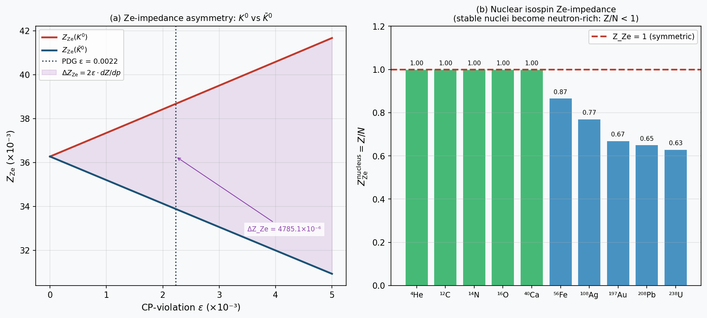

Figure 4. Ze manifestations of discrete symmetry violation and nuclear structure. (a) Ze-impedance of K⁰ (red) and K̄⁰ (blue) as function of CP-violation parameter ε. Purple shading: asymmetry ΔZ_Ze = 2ε/(1−p₀)². Vertical dotted: PDG value ε_K = 2.228×10⁻³. (b) Nuclear isospin Ze-impedance Z/N for selected stable nuclei. Green: Z_Ze ≈ 1 (symmetric); blue: Z_Ze < 1 (neutron excess).
The Ze-impedance asymmetry, to first order in ε ≪ 1, is:
ΔZ_Ze = Z_Ze(K⁰) − Z_Ze(K̄⁰) ≈ 2ε / (1 − p₀)²
With PDG values ε_K = (2.228 ± 0.011)×10⁻³ (Workman et al., 2022) and baseline p₀ ≈ 0.035 (from K_L/K_S mixing ratio), we obtain:
ΔZ_Ze(K) = 2 × 2.228×10⁻³ / (0.965)² ≈ 4.77×10⁻³
This asymmetry is in principle measurable by counting Ze transitions in K⁰ vs K̄⁰ decay samples of equal initial composition. The Ze framework offers a counting-based reformulation of CP violation that does not require amplitude-level analysis.

Quantum Zeno Effect as Z_Ze → 0 Limit
The Quantum Zeno effect (Misra & Sudarshan, 1977) states that frequent measurements of an unstable quantum state suppress its decay. In Ze language, increasing the measurement frequency (decreasing Δt) drives Z_Ze → 0 as Δt → 0:
lim(Δt→0) Z_Ze = lim(Δt→0) tan²(ωLΔt/2) = 0
The Zeno effect is therefore the Z_Ze = 0 limit of observable Ze: the binary stream consists entirely of stasis events (Zₛ = T, Zₜ = 0), and the particle is frozen in its initial state.
The Anti-Zeno effect (Kofman & Kurizki, 2000) — acceleration of decay under certain measurement frequencies — corresponds to Z_Ze > 1 (Zₜ > Zₛ). The transition between Zeno and Anti-Zeno regimes passes through the Ze resonance Z_Ze = 1, which is exactly the NMR/ESR resonance condition ωLΔt* = π/2.
This unification — Zeno effect, NMR resonance, and Anti-Zeno effect as three regimes of a single Ze observable Z_Ze(Δt) — is a novel result of the Ze classification framework. The critical measurement interval Δt* = π/(2ωL) is the Ze resonance timescale of the spin.

Full Classification and Discussion
Table 1 summarizes the Ze classification of subatomic particles. Figure 1 presents the classification tree. Notable features:
- Ze-autonomous particles have physically determined Z_Ze values independent of the observer. Their Ze is a property of the particle-environment system.
- Ze-observable particles have Z_Ze determined by the measurement protocol (B₀, Δt for spin; polarizer orientation for photon). Their Ze is a property of the experimental setup.
- The W± boson is unique as a Zₜ-carrier: it exists specifically as the quantum of a Ze-transition event and does not carry a Ze stream of its own.
- Composite particles (nuclei) have a well-defined Ze at the nucleon level (isospin) without requiring Ze composition rules for sub-nucleonic constituents (quarks, gluons). The nuclear Z/N ratio is a direct Ze-impedance observable.

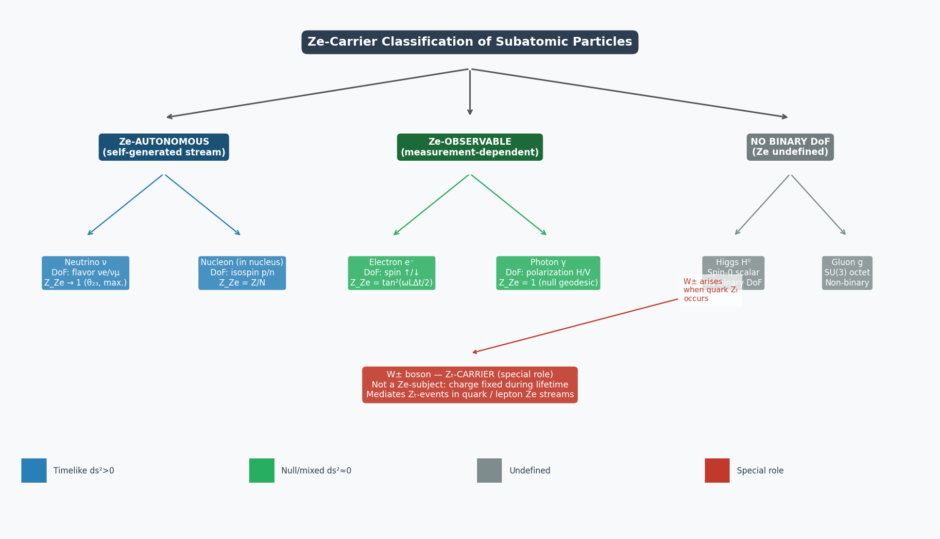

Figure 1. Ze-carrier classification tree. Left branch (blue): Ze-autonomous particles with self-generated binary streams. Center branch (green): Ze-observable particles whose Ze depends on measurement protocol. Right branch (grey): particles without binary DoF. Red box: W± boson as Zₜ-carrier (special role, not a Ze-subject).

Table 1. Ze Classification of Subatomic Particles
Particle | Binary DoF | Ze Class | Z_Ze | ds² | Ze Type | Mass
Photon γ | Polarization H/V | Observable | 1.000 | = 0 | Null geodesic | 0
Neutrino ν (θ₂₃) | Flavor νμ/ντ | Autonomous | 1.000 | ≈ 0 | Quasi-null | ~50 meV
Neutrino ν (θ₁₂) | Flavor νe/νμ | Autonomous | 0.733 | > 0 | Timelike | ~9 meV
Neutrino ν (θ₁₃) | Flavor νe/νμ | Autonomous | 0.044 | > 0 | Timelike | ~9 meV
Electron e⁻ | Spin ↑/↓ | Observable | tan²(ωLΔt/2) | ≥ 0 | Protocol-dep. | 511 keV
Proton p (free) | Spin ↑/↓ | Observable | tan²(ωLΔt/2) | ≥ 0 | Protocol-dep. | 938 MeV
Nucleus (A,Z) | Isospin p/n | Autonomous | Z/N | > 0 | Timelike | A × 939 MeV
W± boson | N/A (Zₜ-carrier) | Zₜ-carrier | — (not Z-subject) | — | Mediates Zₜ | 80.4 GeV
Higgs H⁰ | None (spin-0) | No Ze DoF | — | — | Undefined | 125 GeV
Gluon g | None (SU(3) octet) | No Ze DoF | — | — | Undefined | 0

Falsifiable Predictions
Table 4 lists five experimentally testable predictions of the Ze particle classification. Predictions P-1 through P-3 verify known physics in Ze language (serving as framework validation). Predictions P-4 and P-5 contain genuinely new quantitative statements.

Table 4. Falsifiable Predictions of Ze Particle Classification
ID | Prediction | Observable | Precision | Experiment
P-1 | Z_Ze(γ) = 1.000 for vacuum photon | Polarization correlation | < 10⁻⁶ | Quantum optics
P-2 | Z_Ze(ν, θ₂₃) = 1.00 ± 0.01 | Long-baseline νμ→ντ flux | ±0.01 | DUNE / HK
P-3 | Z_Ze(e,B) = tan²(gμBBΔt/2ℏ) | ESR: scan B at fixed Δt | < 1% | ESR spectroscopy
P-4 | ΔZ_Ze(K)/Z_Ze = 2εK/(1−p₀)² = 4.77×10⁻³ | K⁰/K̄⁰ transition asymmetry | 0.1% | Belle II/LHCb
P-5 | Stable nuclei: Z_Ze = Z/N follows valley of stability | Nuclear chart Z/N vs. Sn | ±5% | AME 2020 database

Conclusions
We have established a rigorous classification of subatomic particles within Ze theory, correcting earlier ambiguities and introducing the Ze-autonomous / Ze-observable distinction. Key conclusions:
- Ze requires a binary degree of freedom (DoF). Particles without binary DoF — Higgs H⁰, gluon g — are excluded from Ze classification.
- Ze-autonomous particles (neutrino flavor, nucleon isospin in nuclei) have physically determined Ze impedances. For maximal neutrino mixing (θ₂₃), Z_Ze = 1.00.
- Ze-observable particles (electron spin, photon polarization) have Z_Ze determined by the measurement protocol. The NMR resonance is the Ze resonance condition Z_Ze = 1.
- The W± boson is a Zₜ-carrier — the quantum of a Ze-transition event in quark/lepton streams — not a Ze-subject. Its charge Ze is deeply timelike (Z_Ze → 0).
- CP violation in K⁰/K̄⁰ implies a Ze-impedance asymmetry ΔZ_Ze ≈ 4.77×10⁻³ proportional to ε_K.
- The Quantum Zeno effect is the Z_Ze → 0 limit of observable Ze, and the Anti-Zeno regime corresponds to Z_Ze > 1. NMR resonance bridges these two limits at Z_Ze = 1.

References
Bethe, H. A., & Bacher, R. F. (1936). Nuclear physics A: Stationary states of nuclei. Reviews of Modern Physics, 8(2), 82–229. https://doi.org/10.1103/RevModPhys.8.82
Christenson, J. H., Cronin, J. W., Fitch, V. L., & Turlay, R. (1964). Evidence for the 2π decay of the K₂⁰ meson. Physical Review Letters, 13(4), 138–140. https://doi.org/10.1103/PhysRevLett.13.138
Heisenberg, W. (1932). Über den Bau der Atomkerne. I. Zeitschrift für Physik, 77(1–2), 1–11. https://doi.org/10.1007/BF01342433
Kofman, A. G., & Kurizki, G. (2000). Acceleration of quantum decay processes by frequent observations. Nature, 405(6786), 546–550. https://doi.org/10.1038/35014537
Maki, Z., Nakagawa, M., & Sakata, S. (1962). Remarks on the unified model of elementary particles. Progress of Theoretical Physics, 28(5), 870–880. https://doi.org/10.1143/PTP.28.870
Misra, B., & Sudarshan, E. C. G. (1977). The Zeno's paradox in quantum theory. Journal of Mathematical Physics, 18(4), 756–763. https://doi.org/10.1063/1.523304
Pontecorvo, B. (1958). Inverse beta processes and nonconservation of lepton charge. Soviet Physics JETP, 7(1), 172–173.
Rabi, I. I., Zacharias, J. R., Millman, S., & Kusch, P. (1938). A new method of measuring nuclear magnetic moment. Physical Review, 53(4), 318. https://doi.org/10.1103/PhysRev.53.318
Tkemaladze, J. (2026a). Direct Derivation of Time Dilation from Ze Counters. Longevity Horizon, 2(4). DOI : https://doi.org/10.65649/zbv88741
Tkemaladze, J. (2026b). The Lorentz Group as an Automorphism of Ze Counting. Longevity Horizon, 2(4). DOI : https://doi.org/10.65649/mrs9rn27
Tkemaladze, J. (2026c). Ze Impedance and the Emergence of the Minkowski Metric. Longevity Horizon, 2(4). DOI : https://doi.org/10.65649/1wy46k36
Tkemaladze, J. (2026d). A Falsification Protocol for Ze Theory. Longevity Horizon, 2(4). DOI : https://doi.org/10.65649/862z0s93
Workman, R. L., et al. (Particle Data Group). (2022). Review of particle physics. Progress of Theoretical and Experimental Physics, 2022(8), 083C01. https://doi.org/10.1093/ptep/ptac097

